HOW DO I READ COMICS IF THERE AREN’T MANY WORDS?

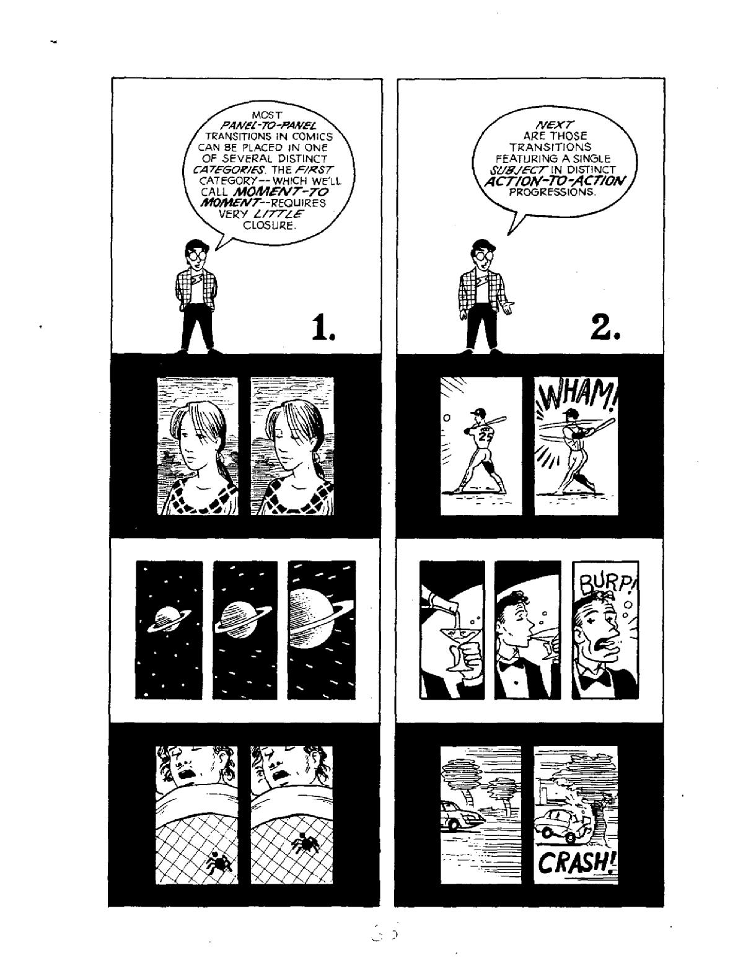

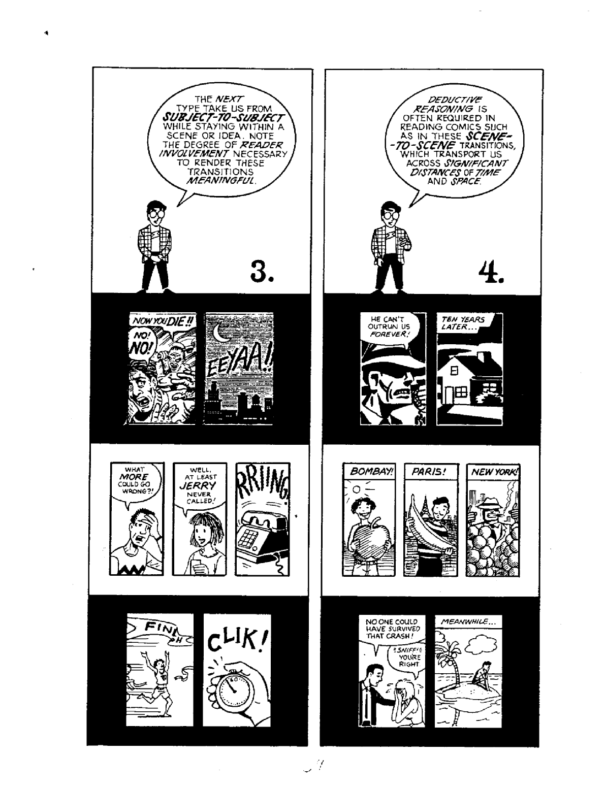

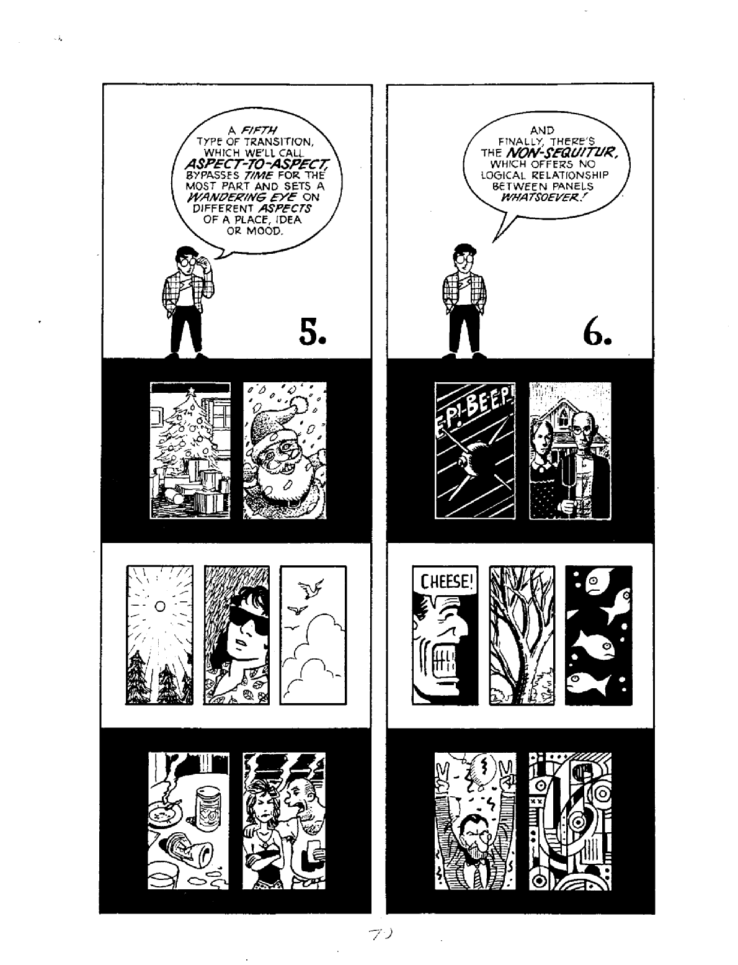
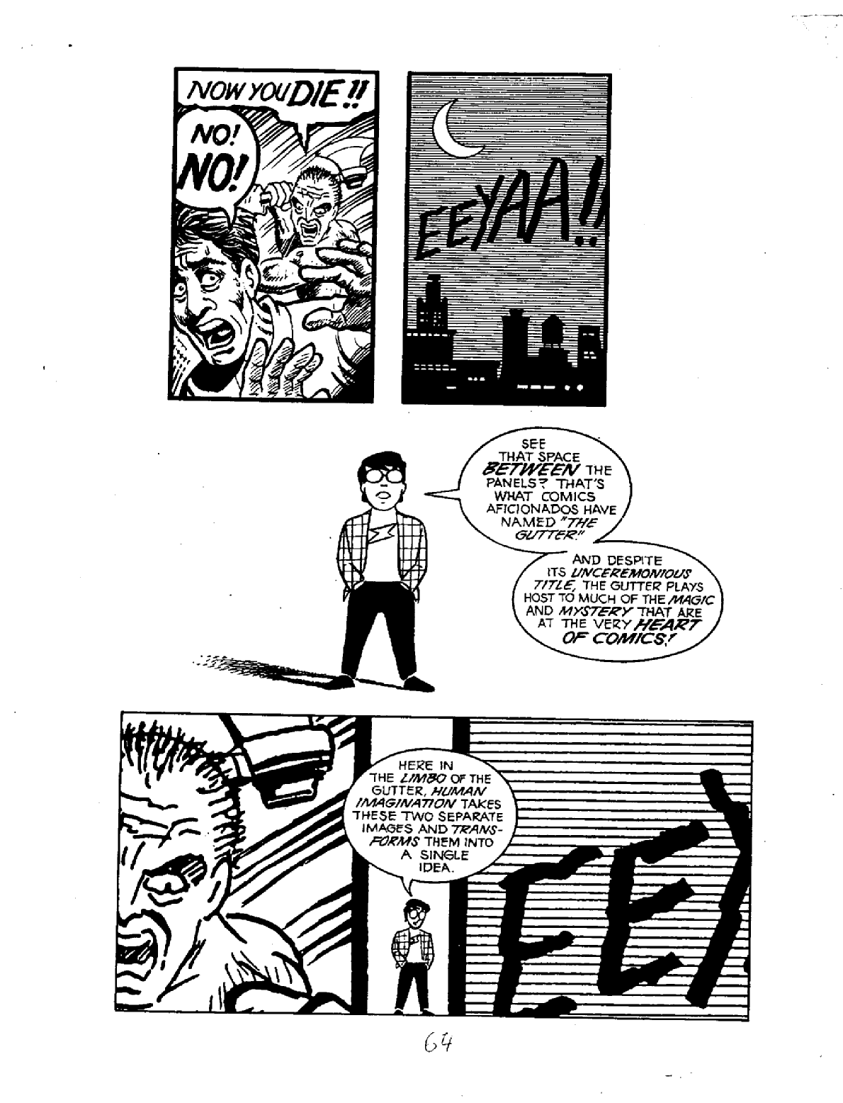

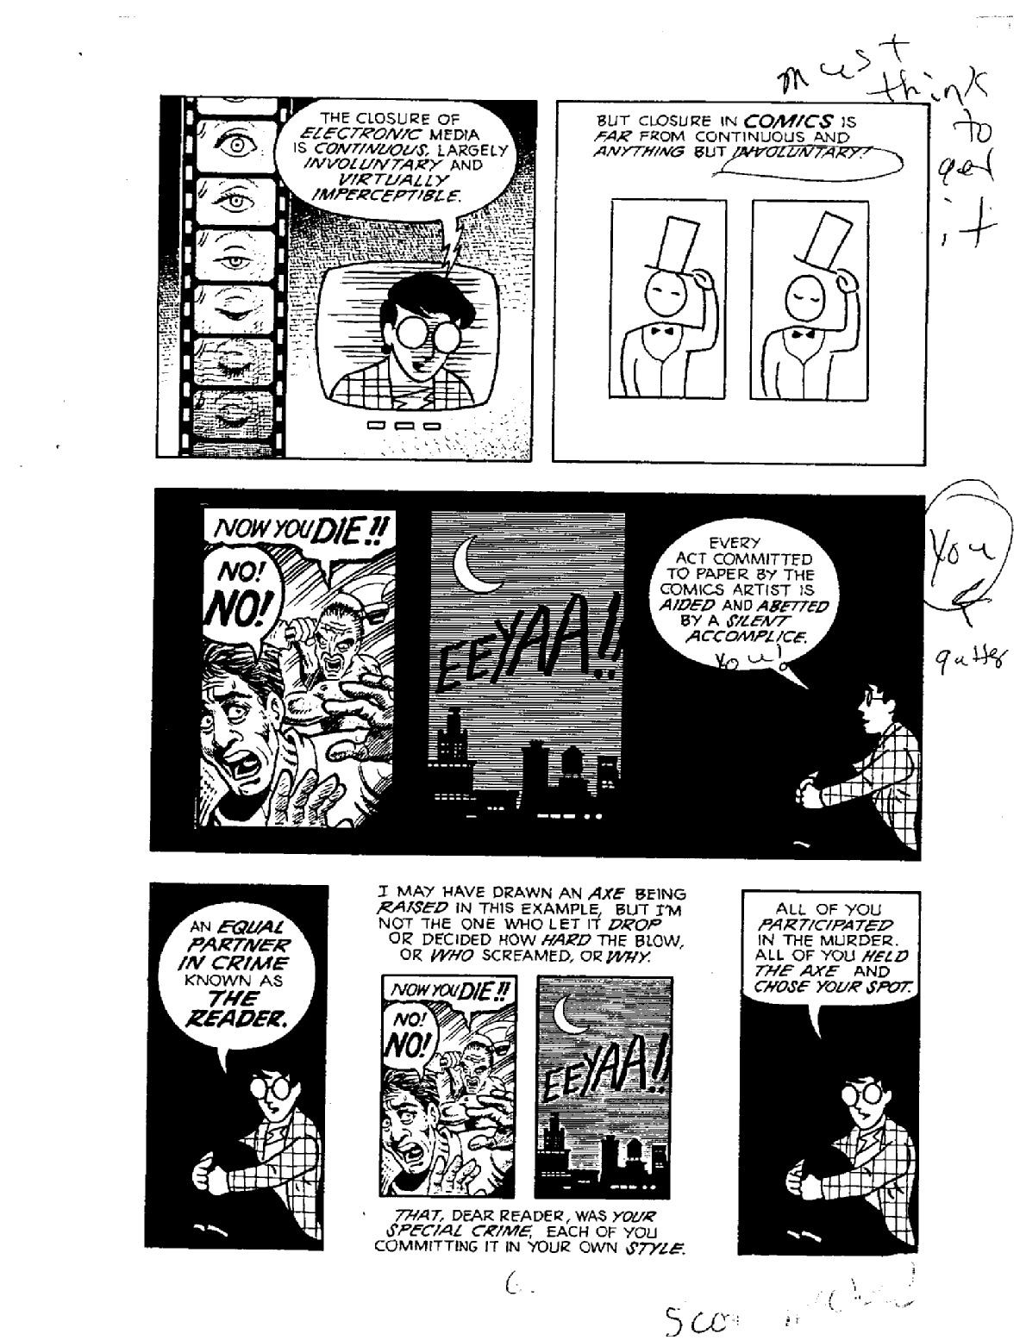

CAN YOU READ THE NEXT FEW STORIES?
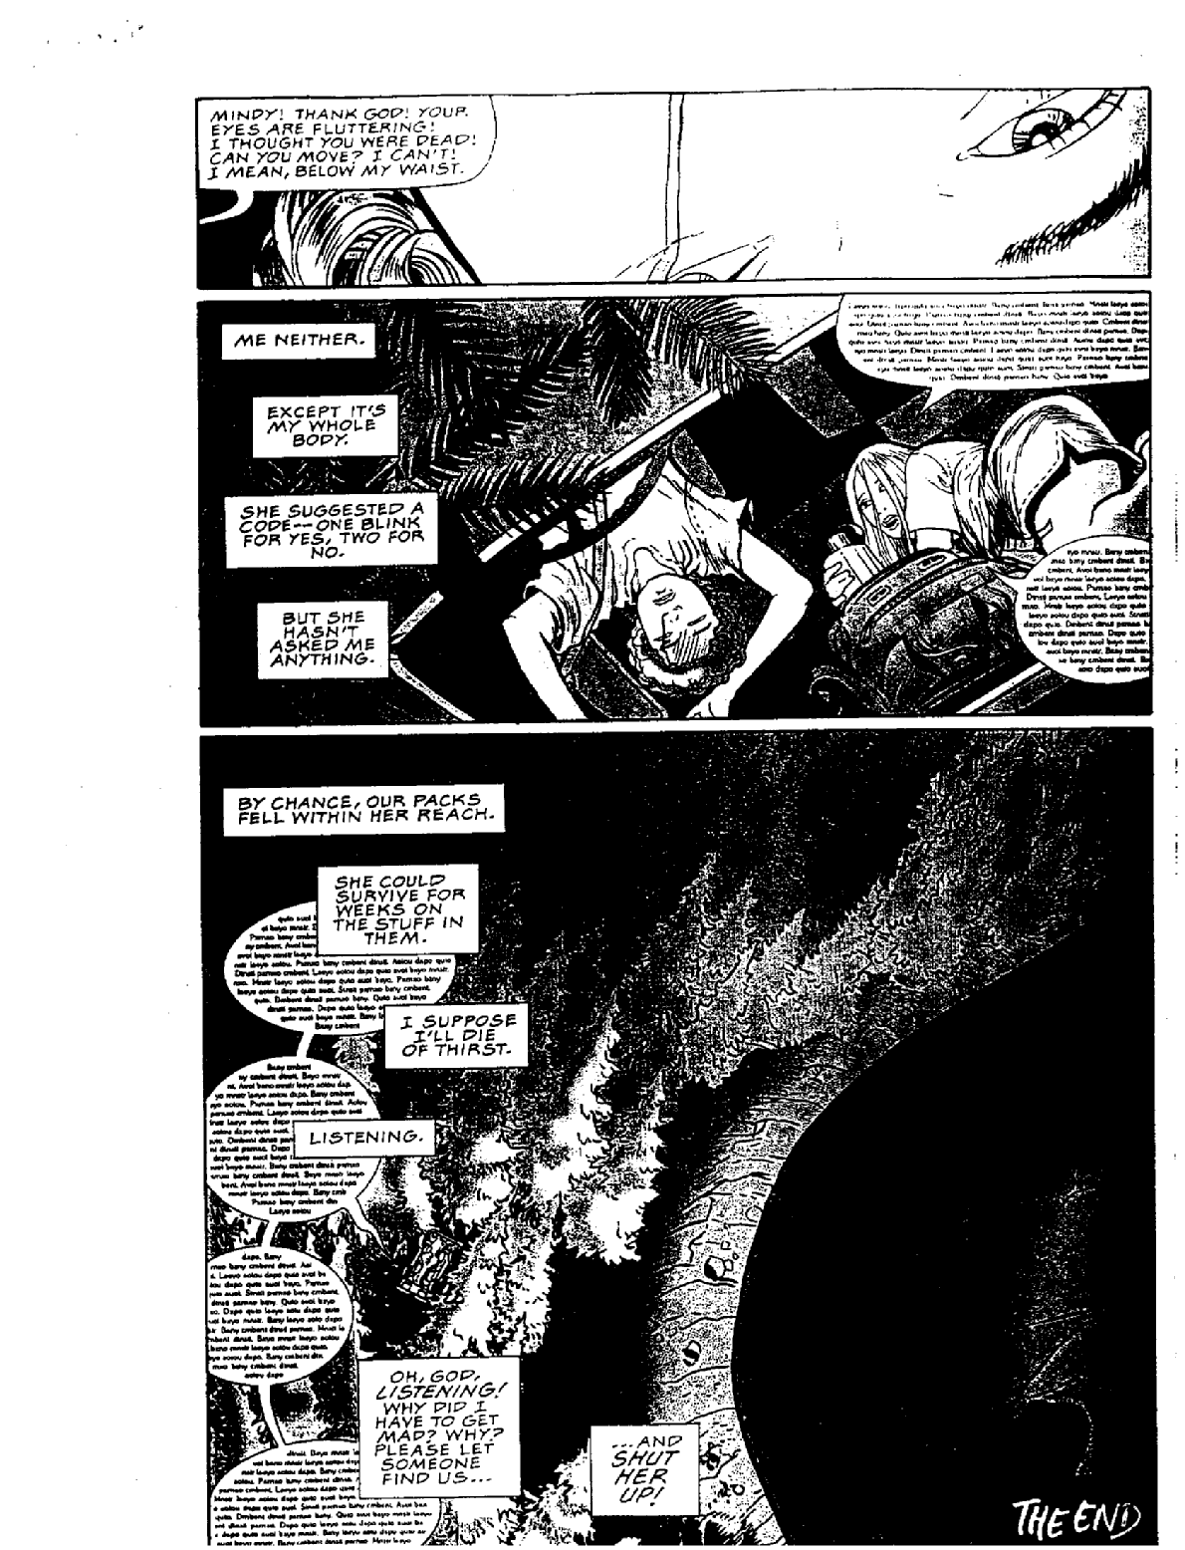

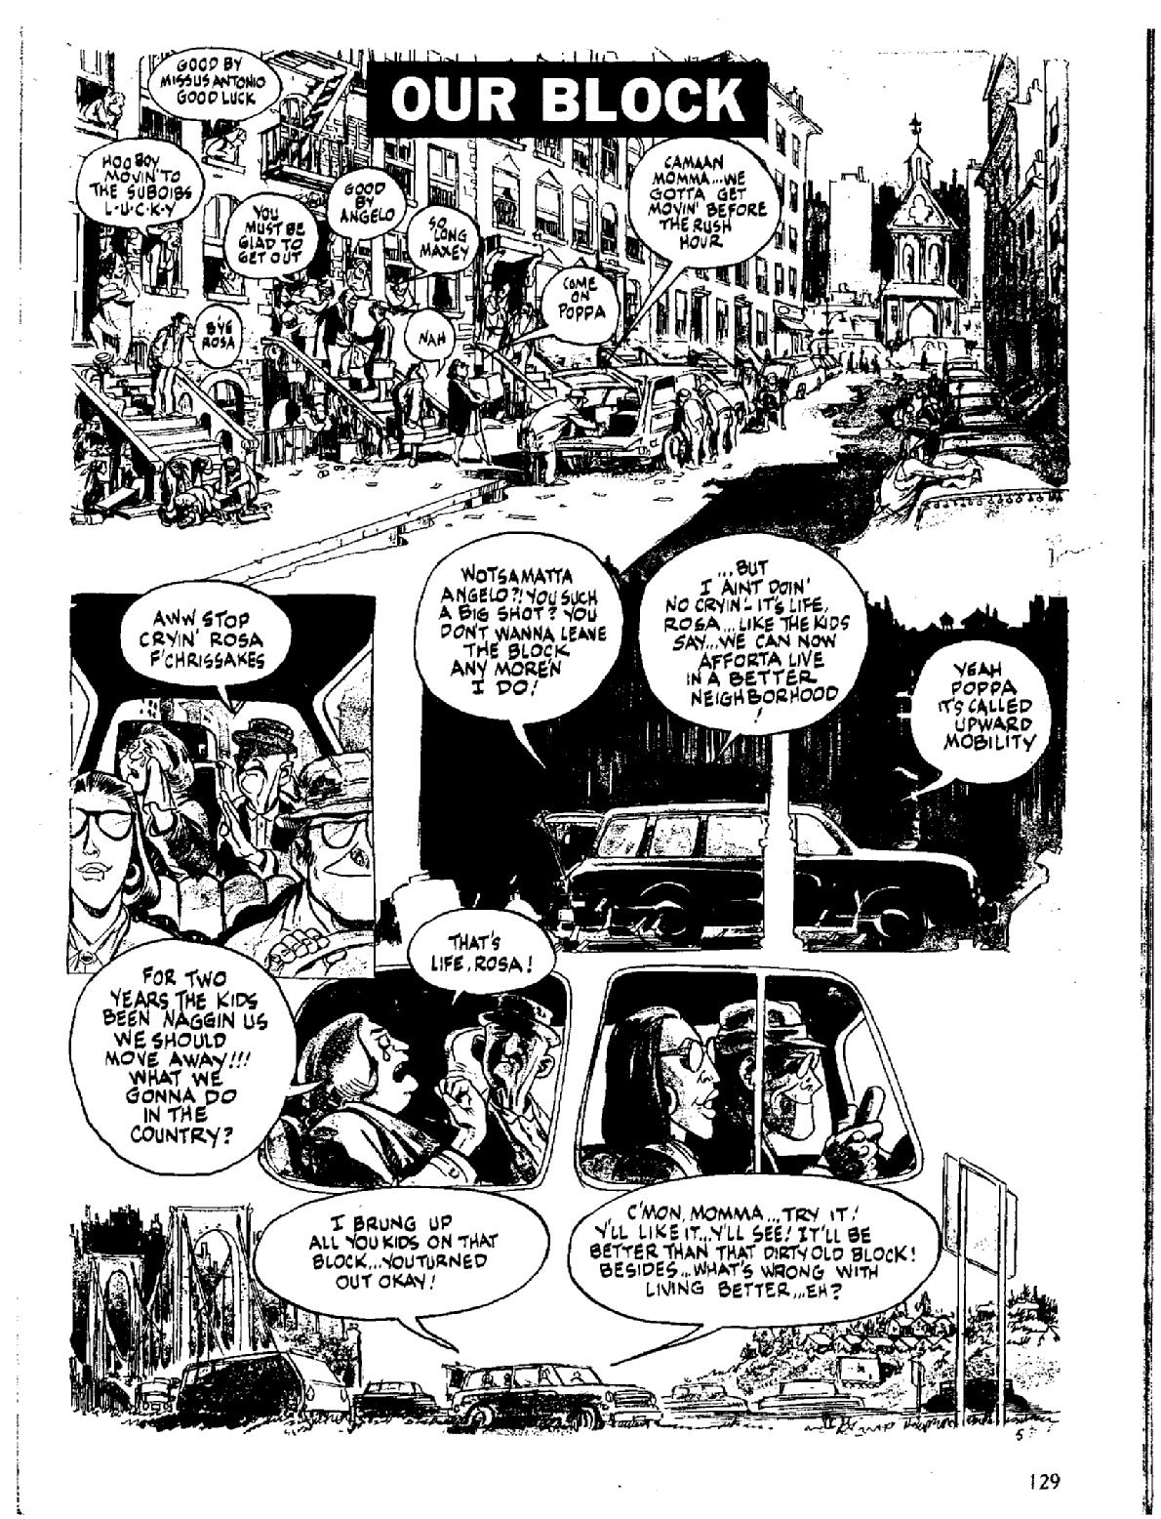

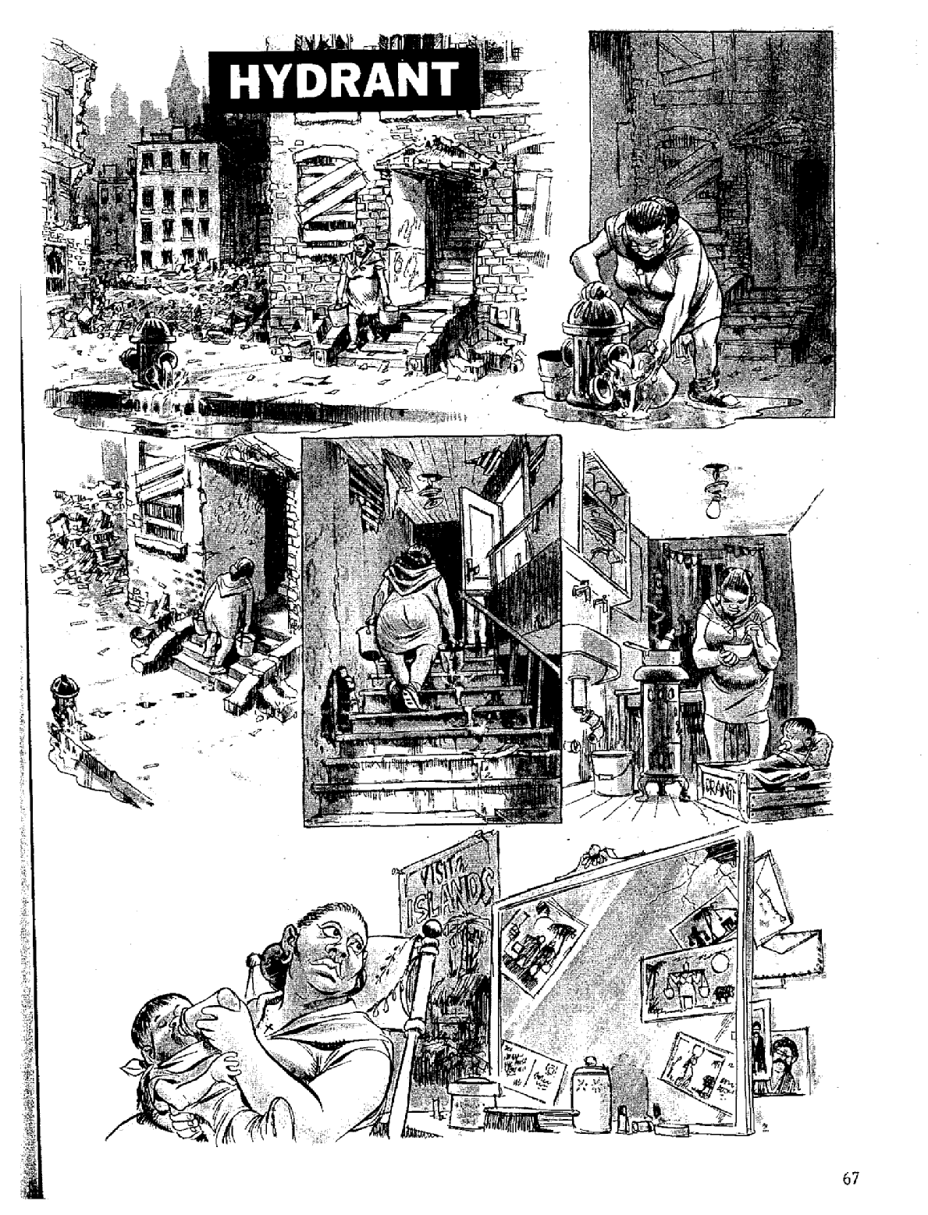

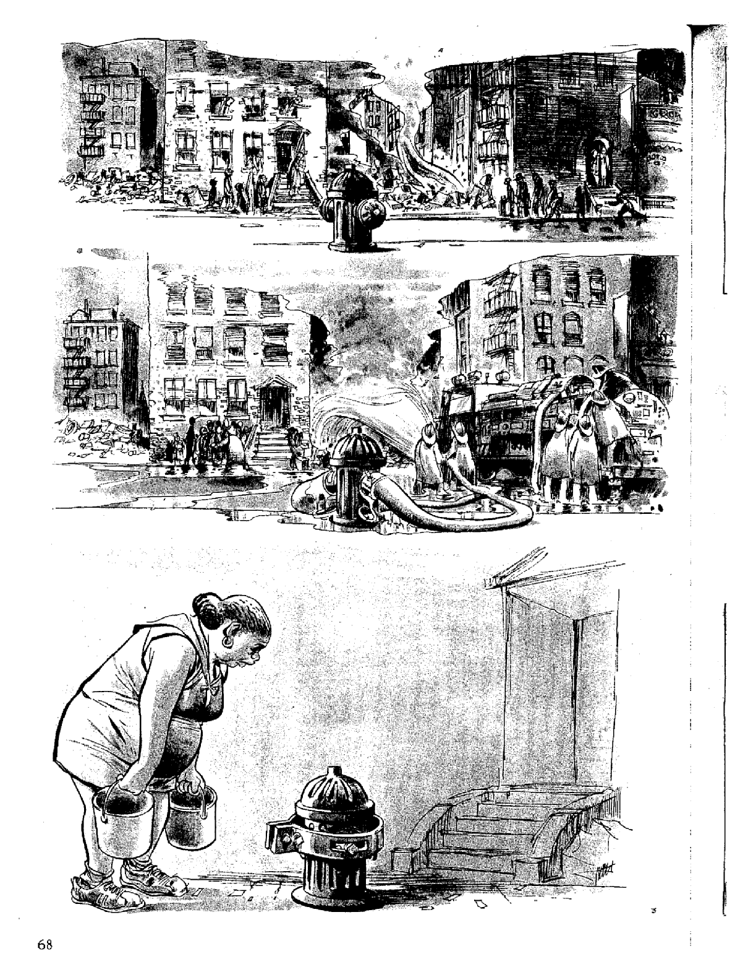

YIKES!! BONUS!!
CAN YOU IDENTIFY ANY OF THIS???? WHAT DOES IT MEAN?????

Agitrons - Wiggly lines around a shaking object or character.

Blurgits, swalloops - Curved lines preceding or trailing after a character's moving limbs.

Briffits - Clouds of dust that hang in the spot of a swiftly departing character or object.

Dites - Diagonal, straight lines drawn across flat, clear, and reflective surfaces, such as windows and mirrors.

Emanata - Lines drawn around the head to indicate shock or surprise.

Grawlixes - Typographical symbols standing for profanities, appearing in dialogue balloons in place of actual Dialogue.

Hites - Horizontal straight lines trailing after something moving with great speed; or, drawn on something indicating reflectivity (puddle, glass, mirror).

Indotherm - Wavy, rising lines used to represent steam or heat. When the same shape is used to denote smell, it is called a Wafteron.

Lucaflect - A shiny spot on a surface of something, depicted as a four-paned window shape

Plewds - Flying sweat droplets that appear around a character's head when working hard, stressed, etc.

Solrads - Radiating lines drawn from something luminous like a lightbulb or the sun.

Squeans - Little starbursts or circles that signify intoxication, dizziness, or sickness.

Vites - Vertical straight lines indicating reflectivity (compare dites, hites).



